**Mindfulness - Application Flow**

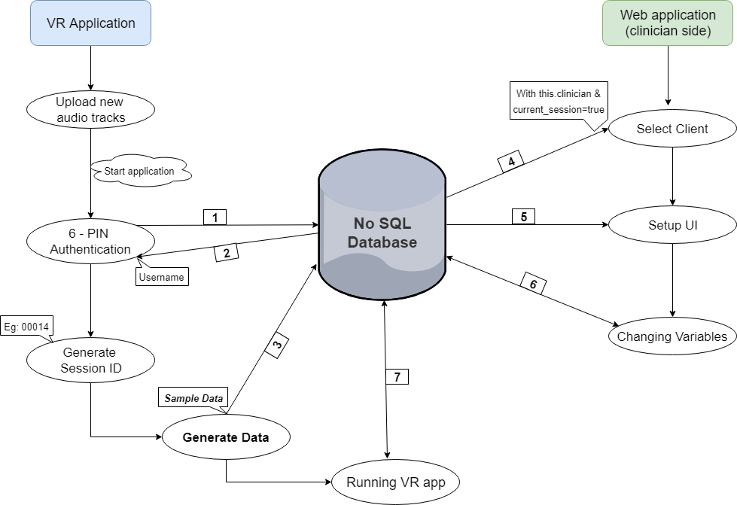

|  |  |
| --- | --- |
| **1** | Once the client enters the 6-digit PIN, System authenticates with database |
| **2** | If authentication is successful, Database returns the username back to the VR app |
| **3** | The generated data is stored under the current username's specific session ID (created in the previous step), on the Database |
| **4** | Queries for clinician's clients and client's Current_session field (=true) and lists them on the web application |
| **5** | Queries the scene and audio settings from the generated data from (3) and displays in a neat UI |
| **6** | Changes made by the clinician on the scene & audio settings is stored into database OR retrieve changed variables from database, set from (7) |
| **7** | Fetches new settings from database, made by (6) and storing changed variables from VR app into database |

**Data Model (JSON format)**

<Username>: {

    <Session_number>: {

        "Current_session": "True/False",

        "Date": "",

        "Audio": {

            "Tracks": ["guide1.mp3", "guide2.mp3", "~NewlyAddedTracks"],

            "Current": "guide1.mp3",

            "Vocal_volume": 0-100,

            "Background_volume": 0-100

        },

        "Scene":{

            "Scene_id": 0,

            "Timeline": 0-24,   //24 Hour format

            "Cloud_speed": 1-10,

            "Breathing": "True/False"

        },

        "Start_timestamp": "~DatTime format",

        "End_timestamp": "~DateTime format",

        "Duration": "~TimeSpan format",

        "Health_monitor": {

            "Start_heartrate": 0,

            "End_heartrate": 0,

            "Max_heartrate": 0,

            "Min_heartrate": 0,

            "Average_heartrate": 0,

            "File": <File_Upload_URL>

        }

    }

}

**Sample Data (JSON format)**

"abhijit.93@hotmail.com":{

    "00011":{

        "Current_session": "False",

        ..

        ..

    },

    "00012":{

        "Current_session": "False",

        ..

        ..

    },

"00014":{

        "Current_session": "True",

        "Date": "",

        "Audio": {

            "Tracks": ["guide1.mp3", "guide2.mp3", "guide3.mp3", "myNewGuide.mp3"],

            "Current": "guide1.mp3",

            "Vocal_volume": 70,

            "Background_volume": 50

        },

        "Scene":{

            "Scene_id": 0,

            "Timeline": 0830,

            "Cloud_speed": 4,

            "Breathing": "True"

        },

        "Start_timestamp": "3/12/2018 10:03:06 PM",

        "End_timestamp": "NA",

        "Duration": "NA",   //"02:14:18 TimeSpan format"

        "Health_monitor": {

            "Start_heartrate": 0,

            "End_heartrate": 0,

            "Max_heartrate": 0,

            "Min_heartrate": 0,

            "Average_heartrate": 0,

            "File": "NA"

        }

    }

},